MINISTRY OF EDUCATION AND TRAINING
HO CHI MINH CITY UNIVERSITY OF TECHNOLOGY AND ENGINEERING
FACULTY OF ADVANCED EDUCATION

TOPIC:
FINAL PROJECT
SUBJECT: DATABASE MANAGEMENT SYSTEM
CLASS: Database management system (2+1)_ Nhom 02FIE
LECTURER: Doc. NGUYỄN THÀNH SƠN
STUDENT: Lê Thanh Đại Dương
STUDENT ID: 24110085

Ho Chi Minh City, June 2026
TOPIC:
FINAL PROJECT
Lecturer’s comment: ..................................................................................................................................................................................................................................................................................................................................................................................................................................................................................................................................................................................................................................................................................................................................................................................................................................................................................................................................................................................................................................................................................................................................................................................................................................................................................................................................................................................................................................................................................................................................................................................................................................................................................................................................................................................................................................................................................................................................................................................................................................................................................................................................................................................................................................................................................................................................................................................................................................................................................................................................................................................................................................................................................................................................................................................................................................................................................................................................................................................................................................................................................................................................................................................................................................................................................................................................................................................................
TABLE OF CONTENTS:
I. INTRODUCTION: 4
1.1. Project Objectives 4
1.2. Technologies Used 4
1.3 Project Structure 4
II. DATABASE DESIGN: 5
2.1. Entity-Relationship Overview: 5
2.2. Table Definitions: 5
III. EXERCISES 9
3.1. Connect Winform to SQL 9
3.1.1. Centralised Connection Class 9
3.1.2. Main Menu and Connection Test 10
3.2. Exercise 1: Stored Procedure – Sum of two integers. 12
3.2.1. Procedure definition. 12
3.2.2. Explain 12
3.2.3. Test cases. 12
3.2.4. WinForm 13
3.3. Exercise 2: Stored Procedure – Book title/edition information query. 16
3.3.1. Procedure definition 16
3.3.2. Explaination 17
3.3.3. Test cases 17
3.3.4. Winform 17
3.4. Exercise 3: Scalar Function – Age calculation 21
3.4.1. Function definition. 21
3.4.2. Explaination. 21
3.4.3. Test cases. 21
3.4.4. Winform. 22
3.5. Exercise 5: Triggers – Automated status updates 25
3.5.1. Trigger tg_insMuon. 25
3.5.2. Trigger tg_delMuon. 26
3.5.3. Trigger tg_updCuonSach. 27
3.5.4. Trigger tg_InfThongBao. 30
3.5.5. Winform 32
IV. DỮ LIỆU MẪU 36
4.1. DocGia 36
4.2. Dausach 36
4.3. Muon 37
V. CONCLUSION 38
5.1. Achievements 38
5.2. Lessons Learned 38
5.3. Future improvements 39

I. INTRODUCTION:

1.1. Project Objectives
This final project for the Database Management Systems course applies theoretical knowledge of Stored Procedures, Scalar Functions, Triggers, and User-defined Functions on Microsoft SQL Server to solve real-world management problems.
I completed 4 out of 6 assigned exercises (Ex1, Ex2, Ex3, Ex5), focusing on a Library Management System.

1.2. Technologies Used
Database System | Microsoft SQL Server (SSMS 2022)
Front-end Applicantion | Window Forms (C#, .NET)
Target Database | QuanLyThuVienMoi
IDE | Visual Studio 2026

1.3 Project Structure
The project is organized into 4 exercises, each targeting a specific database programming concept:
- Exercise 1: Stored Procedure – Sum of two integers.
- Exercise 2: Stored Procedure – Book title/edition information query.
- Exercise 3: Scalar Function – Age calculation.
- Exercise 5: Triggers – Automated status updates (tg_delMuon, tg_insMuon, tg_updCuonSach, tg_InfThongBao).

II. DATABASE DESIGN:

2.1. Entity-Relationship Overview:

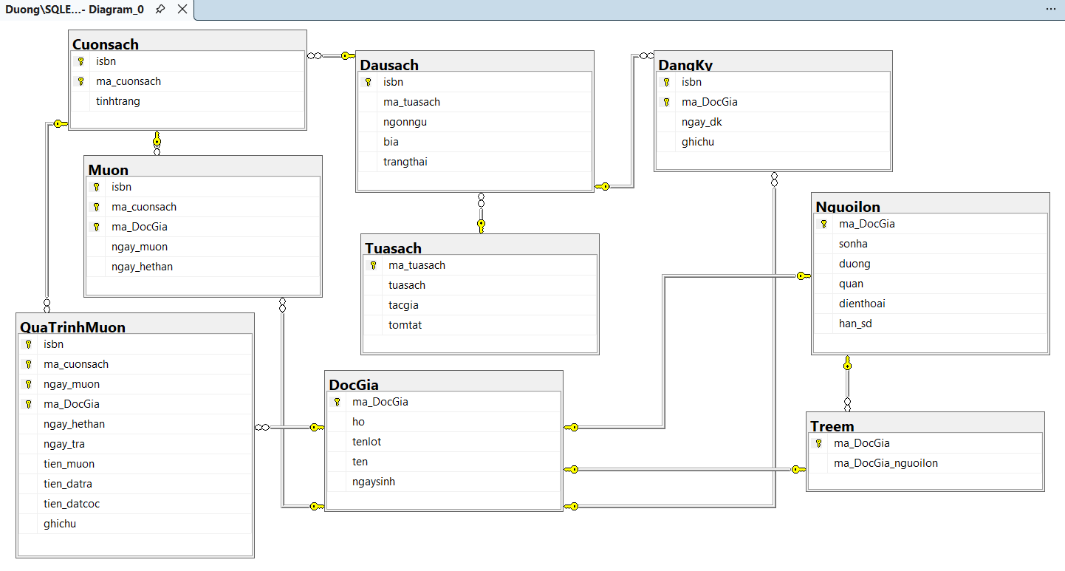
Table summary:
Table | Relationship | Referenced Table
Nguoilon | IS-A (1:1) | DocGia
Treem | IS-A (1:1) + FK to guarantor | DocGia, Nguoilon
Dausach | M:1 edition → title | Tuasach
Cuonsach | M:1 copy → edition | Dausach
DangKy | M:N reservation | Dausach, DocGia
Muon | Active borrow record | Cuonsach, DocGia
QuaTrinhMuon | Historical borrow record | DocGia

2.2. Table Definitions:

Table 1: DocGia
Field | Decription
ma_DocGia | PK, varchar(10), not null
ho | Nvarchar(30), not null
tenlot | Nvarchar(30), null
ten | Nvarchar(20, null
ngaysinh | Date, null

Table 2: Nguoilon
Field | Decription
Ma_DocGia | PK, FK, varchar(10), not null
Sonha | Nvarchar(10), null
Duong | Nvarchar(50), null
quan | Nvarchar(30), null
dienthoai | Varchar(15), null
Han_sd | Date, null

Table 3: Treem
Field | Decription
Ma_DocGia | PK, FK, varchar(10), not null
Ma_DocGia_nguoilon | FK, varchar(10), not null

Table 4: Tuasach
Field | Decription
Ma_tuasach | PK, varchar(10), not null
tuasach | Nvarchar(100), not null
tacgia | Nvarchar(80), null
tomtat | Nvarchar(500), null

Table 5: Dausach
Field | Decription
isbn | PK, varchar(20), not null
Ma_tuasach | FK, varchar(10), not null
ngonngu | Nvarchar(30), null
bia | Nvarchar(10), null
trangthai | Char(3), not null

Table 6: Cuonsach
Field | Decription
isbn | PK, FK, varchar(20), not null
Ma_cuonsach | PK, varchar(10), not null
tinhtrang | Char(3), not null

Table 7: DangKy
Field | Decription
isbn | PK, FK, varchar(20), not null
Ma_DocGia | PK, FK, varchar(10), not null
Ngay_dk | Date, not null
ghichu | Nvarchar(200), null

Table 8: Muon
Field | Decription
isbn | PK, FK, varchar(20), not null
Ma_cuonsach | PK, FK, varchar(10), not null
Ma_DocGia | PK, FK, varchar(10), not null
Ngay_muon | Date, not null
Ngay_hethan | Date, not null

Table 9: QuaTrinhMuon
Field | Decription
isbn | PK, FK, varchar(20), not null
Ma_cuonsach | PK, FK, varchar(10), not null
Ngay_muon | PK, date, not null
Ma_DocGia | PK, FK, varchar(10), not null
Ngay_hethan | Date, not null
Ngay_tra | Date, null
Tien_muon | Decimal(10,2), null
Tien_datra | Decimal(10, 2), null
Tien_datcoc | Decimal(10,2), null
ghichu | Nvarchar(200), null

III. EXERCISES

3.1. Connect Winform to SQL
The WinForms application connects to the QuanLyThuVienMoi database through a centralised helper class DBHelper.cs. All forms share this single connection source, so the connection string only needs to be changed in one place to work across the entire project.

3.1.1. Centralised Connection Class
DBHelper is a static class with two public methods: GetConnection(), which creates and returns a new SqlConnection object, and TestConnection(), which attempts to open that connection and returns true or false depending on success. Every form in the project calls DBHelper.GetConnection() inside a using block to ensure connections are always properly closed and disposed.
public static class DBHelper
{
private static string connectionString =
"Server=DUONG\\SQLEXPRESS;Database=QuanLyThuVienMoi;Trusted_Connection=True;TrustServerCertificate=True;";

public static SqlConnection GetConnection()
{
return new SqlConnection(connectionString);
}

public static bool TestConnection()
{
try
{
using (SqlConnection conn = GetConnection())
{
conn.Open();
return true;
}
}
catch
{
return false;
}
}
}

3.1.2. Main Menu and Connection Test
The main form serves as the navigation hub of the application. It contains a header label, a KET NOI CSDL button, and four exercise navigation buttons (BT1, BT2, BT3, BT5). A status label at the bottom provides live feedback on the connection state.
When the user clicks KET NOI CSDL, the btnKetNoi_Click handler calls DBHelper.TestConnection(). On success, the status label turns green and shows a tick mark; on failure it turns red with an error prompt. Each exercise button opens its corresponding form using ShowDialog(), keeping the main menu visible in the background.
private void btnKetNoi_Click(object sender, EventArgs e)
{
if (DBHelper.TestConnection())
{
lblStatus.Text = "Trạng thái: ✅ Kết nối CSDL thành công!";
lblStatus.ForeColor = System.Drawing.Color.Green;
}
else
{
lblStatus.Text = "Trạng thái: ❌ Kết nối thất bại — kiểm tra SQL Server!";
lblStatus.ForeColor = System.Drawing.Color.Red;
}
}

3.2. Exercise 1: Stored Procedure – Sum of two integers.

3.2.1. Procedure definition.
IF OBJECT_ID('sp_TinhTongHaiSo', 'P') IS NOT NULL
DROP PROCEDURE sp_TinhTongHaiSo;
GO

CREATE PROCEDURE sp_TinhTongHaiSo
@SoThu1 INT,
@SoThu2 INT,
@TongSo INT OUTPUT
AS
BEGIN
SET NOCOUNT ON;
SET @TongSo = @SoThu1 + @SoThu2;
PRINT N'Kết quả: ' + CAST(@SoThu1 AS NVARCHAR) + N' + '
+ CAST(@SoThu2 AS NVARCHAR) + N' = ' + CAST(@TongSo AS NVARCHAR);
END;
GO

3.2.2. Explain
The procedure accepts three parameters: two integer inputs (@SoThu1, @SoThu2) and one integer OUTPUT parameter (@TongSo). The OUTPUT keyword means the caller can read this value back after execution — it is not just used inside the procedure.

3.2.3. Test cases.
-- Kiểm tra BT1:
DECLARE @Tong INT;
EXEC sp_TinhTongHaiSo @SoThu1 = 42, @SoThu2 = 58, @TongSo = @Tong OUTPUT;
SELECT @Tong AS TongHaiSo;

DECLARE @Tong2 INT;
EXEC sp_TinhTongHaiSo @SoThu1 = 100, @SoThu2 = 235, @TongSo = @Tong2 OUTPUT;
SELECT @Tong2 AS TongHaiSo;
GO
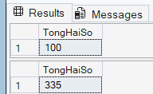

3.2.4. WinForm
The form frmBT1 provides a simple GUI for calling sp_TinhTongHaiSo. It has two TextBox inputs (txtSoA, txtSoB) for the two integers, a TINH TONG button, and a read-only result TextBox (txtKetQua) highlighted in light blue to distinguish it from input fields.
When the user clicks TINH TONG, the handler first validates that both inputs are valid integers using int.TryParse(). It then opens a connection via DBHelper.GetConnection(), creates a SqlCommand set to CommandType.StoredProcedure, adds the two input parameters with AddWithValue(), registers the OUTPUT parameter with ParameterDirection.Output, calls ExecuteNonQuery(), and finally reads the result back from outputParam.Value.
private void btnTinh_Click(object sender, EventArgs e)
{
if (!int.TryParse(txtSoA.Text.Trim(), out int soA))
{
MessageBox.Show("Vui lòng nhập số nguyên hợp lệ cho Số 1!", "Lỗi",
MessageBoxButtons.OK, MessageBoxIcon.Warning);
return;
}
if (!int.TryParse(txtSoB.Text.Trim(), out int soB))
{
MessageBox.Show("Vui lòng nhập số nguyên hợp lệ cho Số 2!", "Lỗi",
MessageBoxButtons.OK, MessageBoxIcon.Warning);
return;
}

try
{
using (SqlConnection conn = DBHelper.GetConnection())
{
conn.Open();
SqlCommand cmd = new SqlCommand("sp_TinhTongHaiSo", conn);
cmd.CommandType = CommandType.StoredProcedure;

// Tên param khớp với SP trong SQL mới
cmd.Parameters.AddWithValue("@SoThu1", soA);
cmd.Parameters.AddWithValue("@SoThu2", soB);

SqlParameter outputParam = new SqlParameter("@TongSo", SqlDbType.Int);
outputParam.Direction = ParameterDirection.Output;
cmd.Parameters.Add(outputParam);

cmd.ExecuteNonQuery();

txtKetQua.Text = outputParam.Value.ToString();
}
}
catch (Exception ex)
{
MessageBox.Show("Lỗi: " + ex.Message, "Lỗi kết nối",
MessageBoxButtons.OK, MessageBoxIcon.Error);
}
}

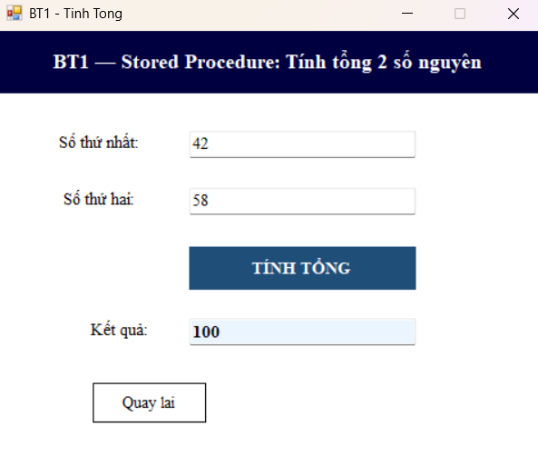
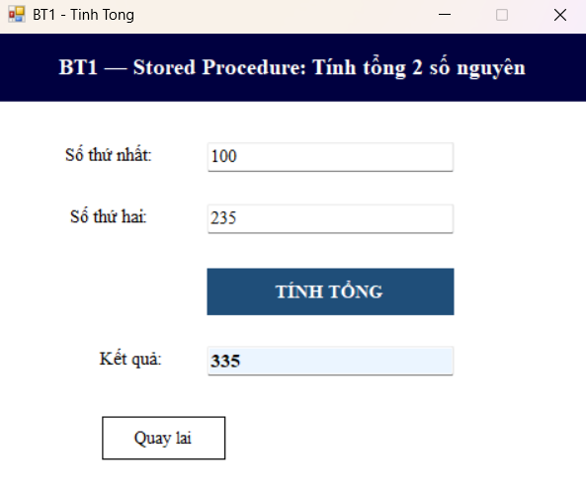

3.3. Exercise 2: Stored Procedure – Book title/edition information query.

3.3.1. Procedure definition
IF OBJECT_ID('sp_ThongtinDausach', 'P') IS NOT NULL
DROP PROCEDURE sp_ThongtinDausach;
GO

CREATE PROCEDURE sp_ThongtinDausach
@isbn VARCHAR(20)
AS
BEGIN
SET NOCOUNT ON;

-- Kiểm tra đầu sách tồn tại
IF NOT EXISTS (SELECT 1 FROM Dausach WHERE isbn = @isbn)
BEGIN
PRINT N'Không tìm thấy đầu sách với ISBN: ' + @isbn;
RETURN;
END

-- Trả về thông tin đầu sách, tựa sách và số cuốn chưa mượn
SELECT
d.isbn AS [ISBN],
t.tuasach AS [Tựa sách],
t.tacgia AS [Tác giả],
t.tomtat AS [Tóm tắt],
d.ngonngu AS [Ngôn ngữ],
d.bia AS [Bìa],
d.trangthai AS [Trạng thái đầu sách],
(
SELECT COUNT(*)
FROM Cuonsach cs
WHERE cs.isbn = d.isbn
AND cs.tinhtrang = 'yes'
) AS [Số cuốn chưa mượn]
FROM Dausach d
JOIN Tuasach t ON t.ma_tuasach = d.ma_tuasach
WHERE d.isbn = @isbn;
END;
GO

3.3.2. Explaination
The procedure receives a single VARCHAR ISBN parameter and first checks whether that ISBN exists in the Dausach table. If not, it prints a Vietnamese not-found message and exits early with RETURN, avoiding a null result set being sent back to the caller.
The main SELECT joins Dausach with Tuasach to retrieve edition and title metadata in one query. A correlated subquery in the SELECT clause counts only the physical copies (Cuonsach rows) for that same ISBN where tinhtrang = 'yes', giving the live availability count without a separate query.

3.3.3. Test cases
-- Kiểm tra BT2:
EXEC sp_ThongtinDausach @isbn = 'ISBN-PY01'; -- Có cuốn chưa mượn
EXEC sp_ThongtinDausach @isbn = 'ISBN-AI01'; -- Hết sách (trangthai = no)
EXEC sp_ThongtinDausach @isbn = 'ISBN-XXXX'; -- Không tồn tại
GO

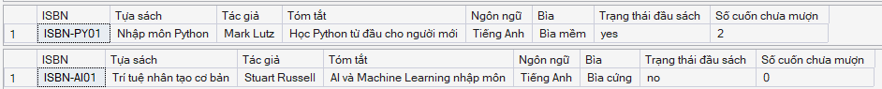

3.3.4. Winform
The form frmBT2 lets the user type an ISBN into a TextBox and click TIM KIEM to query the database. Results are displayed in a DataGridView with dark-blue styled column headers and auto-sized columns.
The handler validates that the ISBN field is not empty, then calls sp_ThongtinDausach via a SqlCommand with CommandType.StoredProcedure. A SqlDataAdapter fills a DataTable with the returned result set, which is then bound directly to dgvKetQua.DataSource. If the DataTable is empty, a MessageBox informs the user and the grid is cleared.
private void btnTimKiem_Click(object sender, EventArgs e)
{
string isbn = txtISBN.Text.Trim();
if (string.IsNullOrEmpty(isbn))
{
MessageBox.Show("Vui lòng nhập ISBN!", "Cảnh báo",
MessageBoxButtons.OK, MessageBoxIcon.Warning);
return;
}

try
{
using (SqlConnection conn = DBHelper.GetConnection())
{
conn.Open();
SqlCommand cmd = new SqlCommand("sp_ThongtinDausach", conn);
cmd.CommandType = CommandType.StoredProcedure;
cmd.Parameters.AddWithValue("@isbn", isbn);

SqlDataAdapter da = new SqlDataAdapter(cmd);
DataTable dt = new DataTable();
da.Fill(dt);

if (dt.Rows.Count == 0)
{
MessageBox.Show("Không tìm thấy đầu sách với ISBN: " + isbn,
"Thông báo", MessageBoxButtons.OK, MessageBoxIcon.Information);
dgvKetQua.DataSource = null;
}
else
{
dgvKetQua.DataSource = dt;
}
}
}
catch (Exception ex)
{
MessageBox.Show("Lỗi: " + ex.Message, "Lỗi kết nối",
MessageBoxButtons.OK, MessageBoxIcon.Error);
}
}

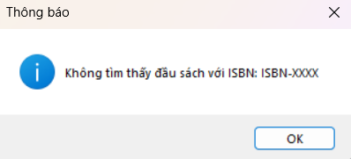
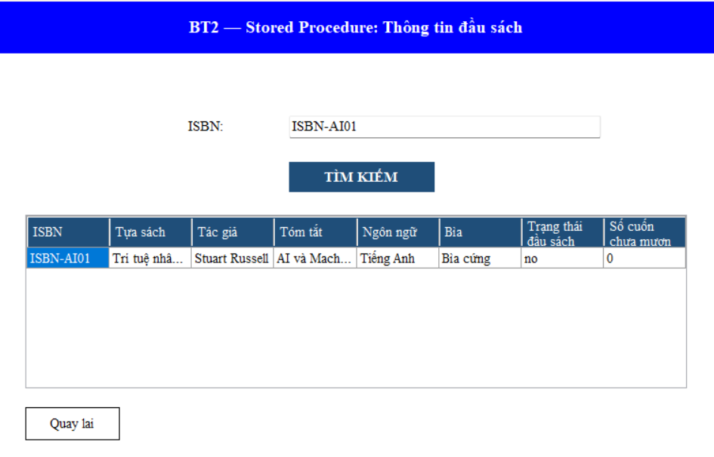
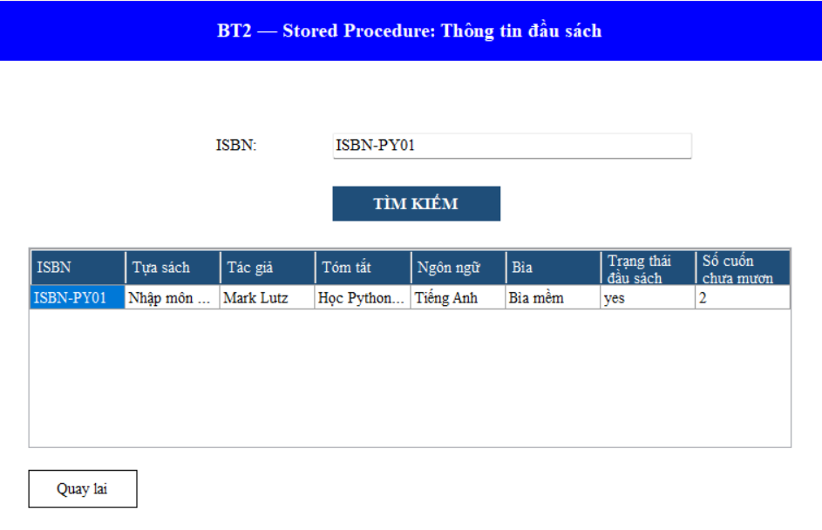

3.4. Exercise 3: Scalar Function – Age calculation

3.4.1. Function definition.
IF OBJECT_ID('fn_TinhTuoi', 'FN') IS NOT NULL
DROP FUNCTION fn_TinhTuoi;
GO

CREATE FUNCTION fn_TinhTuoi
(
@NamSinh INT
)
RETURNS INT
AS
BEGIN
DECLARE @Tuoi INT;
-- Tính đơn giản: năm hiện tại trừ năm sinh
SET @Tuoi = YEAR(GETDATE()) - @NamSinh;
RETURN @Tuoi;
END;
GO

3.4.2. Explaination.
fn_TinhTuoi is a Scalar User-Defined Function — it takes one integer parameter (@NamSinh, the birth year) and returns a single integer. Unlike stored procedures, scalar functions can be called directly inside a SELECT statement without ExecuteNonQuery(). The dbo. schema prefix is mandatory when calling UDFs from DML queries.

3.4.3. Test cases.
-- Kiểm tra BT3:
SELECT dbo.fn_TinhTuoi(1995) AS [Tuổi (sinh 1995)];
SELECT dbo.fn_TinhTuoi(2005) AS [Tuổi (sinh 2005)];
SELECT dbo.fn_TinhTuoi(1975) AS [Tuổi (sinh 1975)];

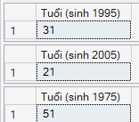

3.4.4. Winform.
The form frmBT3 has a single TextBox for the birth year input, a TINH TUOI button, and a read-only result TextBox. The handler performs two rounds of validation: first checking that the input is a valid integer, then verifying it falls in the realistic range of 1900 to the current year.
Unlike the stored procedure forms, frmBT3 calls the function inline using a plain SELECT statement — SELECT dbo.fn_TinhTuoi(@NamSinh) — with ExecuteScalar() to retrieve the single returned integer. The result is then formatted as a readable string (e.g. '31 tuổi') and shown in the read-only output box.
private void btnTinhTuoi_Click(object sender, EventArgs e)
{
if (!int.TryParse(txtNamSinh.Text.Trim(), out int namSinh))
{
MessageBox.Show("Vui lòng nhập năm sinh là số nguyên hợp lệ!",
"Cảnh báo", MessageBoxButtons.OK, MessageBoxIcon.Warning);
return;
}

int namHienTai = DateTime.Now.Year;
if (namSinh < 1900 || namSinh > namHienTai)
{
MessageBox.Show($"Năm sinh phải từ 1900 đến {namHienTai}!",
"Cảnh báo", MessageBoxButtons.OK, MessageBoxIcon.Warning);
return;
}

try
{
using (SqlConnection conn = DBHelper.GetConnection())
{
conn.Open();
SqlCommand cmd = new SqlCommand(
"SELECT dbo.fn_TinhTuoi(@NamSinh)", conn);
cmd.Parameters.AddWithValue("@NamSinh", namSinh);

int tuoi = Convert.ToInt32(cmd.ExecuteScalar());
txtKetQua.Text = tuoi + " tuổi";
}
}
catch (Exception ex)
{
MessageBox.Show("Lỗi: " + ex.Message, "Lỗi kết nối",
MessageBoxButtons.OK, MessageBoxIcon.Error);
}
}

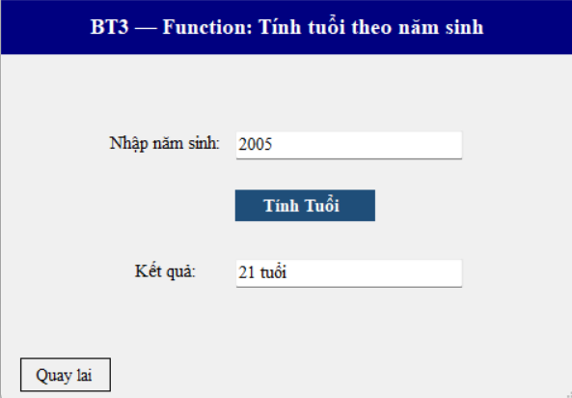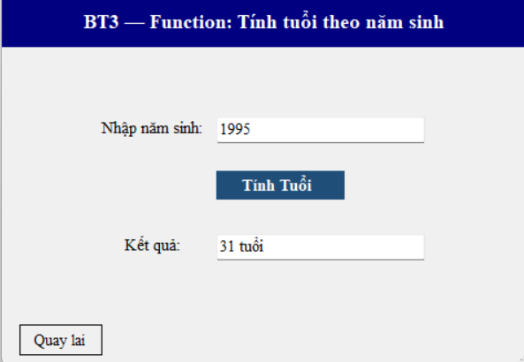

3.5. Exercise 5: Triggers – Automated status updates

3.5.1. Trigger tg_insMuon.
IF OBJECT_ID('tg_insMuon', 'TR') IS NOT NULL
DROP TRIGGER tg_insMuon;
GO

CREATE TRIGGER tg_insMuon
ON Muon
AFTER INSERT
AS
BEGIN
SET NOCOUNT ON;

UPDATE Cuonsach
SET tinhtrang = 'no'
FROM Cuonsach cs
JOIN INSERTED i ON i.isbn = cs.isbn
AND i.ma_cuonsach = cs.ma_cuonsach;

PRINT N'[tg_insMuon] Đã cập nhật tình trạng cuốn sách thành "no" (đang mượn).';
END;
GO

When a new row is inserted into Muon, this trigger fires and sets tinhtrang = 'no' on the matching Cuonsach row. The INSERTED virtual table holds the newly inserted borrow record, allowing the trigger to identify exactly which physical copy to update without any additional query.
BEGIN TRAN;
-- DG105 mượn cuốn DM CS-E01 (đang sẵn sàng)
INSERT INTO Muon VALUES ('ISBN-DM01','CS-E01','DG105','2026-06-10','2026-06-24');

-- Kỳ vọng: CS-E01 chuyển sang 'no'
SELECT isbn, ma_cuonsach, tinhtrang
FROM Cuonsach
WHERE isbn = 'ISBN-DM01';
ROLLBACK;
GO
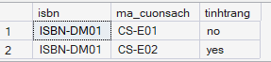

3.5.2. Trigger tg_delMuon.
IF OBJECT_ID('tg_delMuon', 'TR') IS NOT NULL
DROP TRIGGER tg_delMuon;
GO

CREATE TRIGGER tg_delMuon
ON Muon
AFTER DELETE
AS
BEGIN
SET NOCOUNT ON;

-- Mỗi cuốn sách bị xóa khỏi Muon → đặt lại tình trạng = sẵn sàng
UPDATE Cuonsach
SET tinhtrang = 'yes'
FROM Cuonsach cs
JOIN DELETED d ON d.isbn = cs.isbn
AND d.ma_cuonsach = cs.ma_cuonsach;

PRINT N'[tg_delMuon] Đã cập nhật tình trạng cuốn sách thành "yes" (sẵn sàng).';
END;
GO

This is the counterpart to tg_insMuon. When a borrow record is deleted from Muon, the DELETED virtual table holds the removed row. The trigger uses it to restore the matching physical copy's tinhtrang back to 'yes', making it available for future borrowing.
BEGIN TRAN;
DELETE FROM Muon
WHERE isbn = 'ISBN-PY01'
AND ma_cuonsach = 'CS-A02'
AND ma_DocGia = 'DG101';

-- Kỳ vọng: CS-A02 chuyển về 'yes'
SELECT isbn, ma_cuonsach, tinhtrang
FROM Cuonsach
WHERE isbn = 'ISBN-PY01';
ROLLBACK;
GO
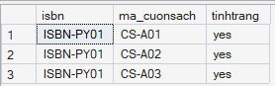

3.5.3. Trigger tg_updCuonSach.
IF OBJECT_ID('tg_updCuonSach', 'TR') IS NOT NULL
DROP TRIGGER tg_updCuonSach;
GO

CREATE TRIGGER tg_updCuonSach
ON Cuonsach
AFTER UPDATE
AS
BEGIN
SET NOCOUNT ON;

IF NOT UPDATE(tinhtrang) RETURN;

DECLARE @isbn VARCHAR(20);

DECLARE cur_isbn CURSOR FOR
SELECT DISTINCT isbn FROM INSERTED;

OPEN cur_isbn;
FETCH NEXT FROM cur_isbn INTO @isbn;

WHILE @@FETCH_STATUS = 0
BEGIN
DECLARE @SoCuonSan INT;
SELECT @SoCuonSan = COUNT(*)
FROM Cuonsach
WHERE isbn = @isbn AND tinhtrang = 'yes';

IF @SoCuonSan > 0
UPDATE Dausach SET trangthai = 'yes' WHERE isbn = @isbn;
ELSE
UPDATE Dausach SET trangthai = 'no' WHERE isbn = @isbn;

PRINT N'[tg_updCuonSach] Đã cập nhật trangthai Dausach cho ISBN: ' + @isbn;

FETCH NEXT FROM cur_isbn INTO @isbn;
END;

CLOSE cur_isbn;
DEALLOCATE cur_isbn;
END;
GO

This trigger fires on the Cuonsach table whenever a physical copy's status changes. It checks IF NOT UPDATE RETURN to skip execution if unrelated columns were updated, saving unnecessary work. For each affected ISBN it counts the remaining available copies: if at least one exists the edition's trangthai is set to 'yes'; otherwise 'no'. A CURSOR handles batch updates where multiple ISBNs are affected in one statement.
BEGIN TRAN;
-- Đặt toàn bộ cuốn ISBN-DM01 thành 'no'
UPDATE Cuonsach SET tinhtrang = 'no' WHERE isbn = 'ISBN-DM01';

-- Kỳ vọng: trangthai Dausach ISBN-DM01 chuyển sang 'no'
SELECT isbn, trangthai FROM Dausach WHERE isbn = 'ISBN-DM01';
ROLLBACK;
GO

BEGIN TRAN;
-- Trả lại 1 cuốn ISBN-AI01 → 'yes'
UPDATE Cuonsach SET tinhtrang = 'yes'
WHERE isbn = 'ISBN-AI01' AND ma_cuonsach = 'CS-C01';

-- Kỳ vọng: trangthai Dausach ISBN-AI01 chuyển sang 'yes'
SELECT isbn, trangthai FROM Dausach WHERE isbn = 'ISBN-AI01';
ROLLBACK;
GO
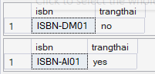

3.5.4. Trigger tg_InfThongBao.
IF OBJECT_ID('tg_InfThongBao', 'TR') IS NOT NULL
DROP TRIGGER tg_InfThongBao;
GO

CREATE TRIGGER tg_InfThongBao
ON Tuasach
AFTER INSERT, UPDATE
AS
BEGIN
SET NOCOUNT ON;

IF EXISTS (SELECT 1 FROM INSERTED)
BEGIN
IF EXISTS (SELECT 1 FROM DELETED)
BEGIN
-- Trường hợp UPDATE: kiểm tra tựa sách hoặc tác giả có thay đổi
IF UPDATE(tuasach) OR UPDATE(tacgia)
PRINT N'Đã thêm mới tựa sách';
END
ELSE
BEGIN
-- Trường hợp INSERT mới
PRINT N'Đã thêm mới tựa sách';
END
END
END;
GO

This trigger fires on both INSERT and UPDATE on the Tuasach table and prints the message 'Da them moi tua sach' to the messages pane. The trigger distinguishes the operation type by checking the DELETED table — on INSERT, DELETED is empty; on UPDATE, DELETED holds the pre-update row. The IF UPDATE OR UPDATE condition ensures the notification only fires when the title name or author are actually changed, not on every update to any column.
BEGIN TRAN;
-- INSERT tựa sách mới
INSERT INTO Tuasach VALUES
('TS106', N'Bảo mật hệ thống thông tin', N'William Stallings', N'An ninh mạng và mã hóa');

-- UPDATE tên tác giả
UPDATE Tuasach
SET tacgia = N'Lê Anh Tuấn'
WHERE ma_tuasach = 'TS101';

-- UPDATE tựa sách
UPDATE Tuasach
SET tuasach = N'Nhập môn Python (Tái bản lần 3)'
WHERE ma_tuasach = 'TS101';
ROLLBACK;
GO
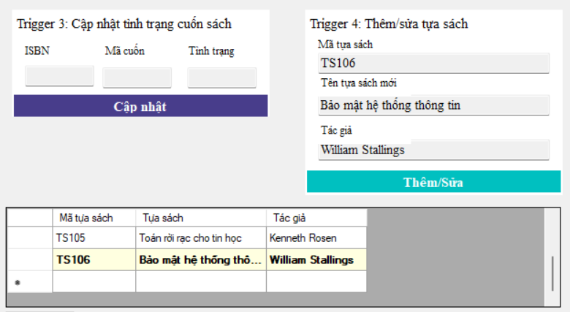
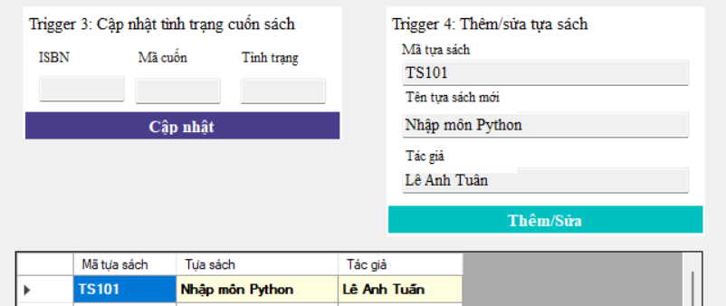

3.5.5. Winform
The form frmBT5 provides a tabbed panel layout with four sections, one per trigger. Each section has the necessary input fields and an action button. A shared DataGridView at the bottom of the form refreshes after every action to show the current state of the affected rows, with the most recently modified row highlighted in yellow-bold for visibility.
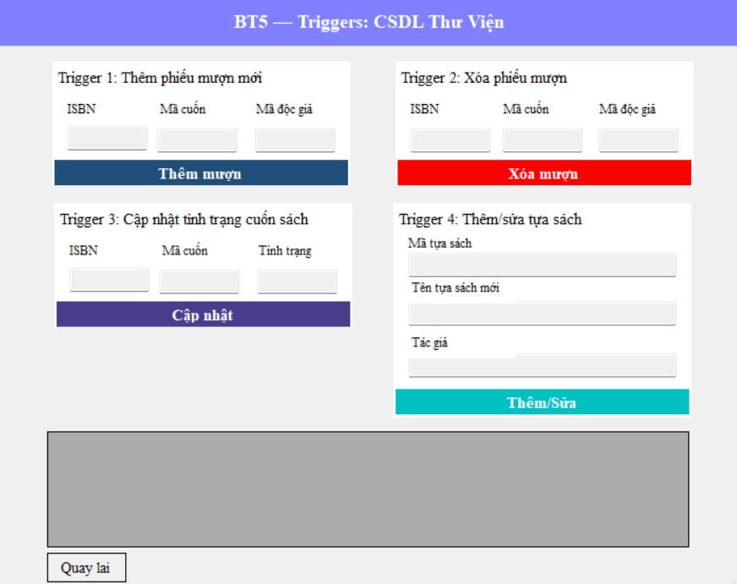
The LoadKetQua() private method is called after every successful operation to reload the DataGridView. It queries Cuonsach joined with Dausach filtered by the relevant ISBN, then iterates through the grid rows to apply the yellow highlight on the specific copy that was just modified.
private void LoadKetQua(string isbn, string maCuon)
{
try
{
using (SqlConnection conn = DBHelper.GetConnection())
{
conn.Open();
string query = @"
SELECT
cs.isbn AS [ISBN],
cs.ma_cuonsach AS [Mã cuốn],
cs.tinhtrang AS [Tình trạng cuốn],
ds.trangthai AS [Trạng thái đầu sách]
FROM Cuonsach cs
JOIN Dausach ds ON ds.isbn = cs.isbn
WHERE cs.isbn = @isbn";

SqlDataAdapter da = new SqlDataAdapter(query, conn);
da.SelectCommand.Parameters.AddWithValue("@isbn", isbn);
DataTable dt = new DataTable();
da.Fill(dt);

dgvKetQua.DataSource = dt;
dgvKetQua.AutoResizeColumns(DataGridViewAutoSizeColumnsMode.AllCells);

// Highlight dòng vừa thao tác
foreach (DataGridViewRow row in dgvKetQua.Rows)
{
if (row.Cells["Mã cuốn"].Value?.ToString() == maCuon)
{
row.DefaultCellStyle.BackColor = Color.LightYellow;
row.DefaultCellStyle.Font = new Font(dgvKetQua.Font, FontStyle.Bold);
}
}
}
}
catch (Exception ex)
{
MessageBox.Show("Lỗi load kết quả: " + ex.Message, "Lỗi",
MessageBoxButtons.OK, MessageBoxIcon.Error);
}
}

IV. DỮ LIỆU MẪU

4.1. DocGia
ma_DocGia | Ho | Tenlot | Ten | Ngaysinh
DG101 | Võ | Thanh | Hải | 1982-06-10
DG102 | Đinh | Thị | Ngọc | 1994-02-28
DG103 | Bùi | Quốc | Tuấn | 2014-08-17 (child)
DG104 | Ngô | Minh | Khoa | 2016-12-01 (child)
DG105 | Dương | Thị | Thanh | 1975-05-20
DG106 | Trịnh | Văn | Hùng | 1988-10-03

4.2. Dausach
ISBN | Title (Tựa sách) | Language | Initial Status
ISBN-PY01 | Nhập môn Python | Tiếng Anh | yes (2 of 3 available)
ISBN-SA01 | Kiến trúc phần mềm hiện đại | Tiếng Việt | yes (2 of 2 available)
ISBN-AI01 | Trí tuệ nhân tạo cơ bản | Tiếng Anh | no (0 of 2 available)
ISBN-OS01 | Hệ điều hành | Tiếng Việt | yes (1 of 2 available)
ISBN-DM01 | Toán rời rạc cho tin học | Tiếng Việt | yes (2 of 2 available)

4.3. Muon
ISBN | Copy | Reader | Borrow Date | Due Date
ISBN-PY01 | CS-A02 | DG101 | 2026-03-15 | 2026-03-29 (OVERDUE ~73d)
ISBN-AI01 | CS-C01 | DG102 | 2026-05-22 | 2026-06-05 (overdue 5d)
ISBN-AI01 | CS-C02 | DG103 | 2026-05-28 | 2026-06-11 (child)
ISBN-OS01 | CS-D02 | DG106 | 2026-06-03 | 2026-06-17 (current)

V. CONCLUSION

5.1. Achievements
- Successfully designed and implemented a normalized relational database schema for a library management system with nine interrelated tables and proper foreign key constraints.
- Developed and tested five Stored Procedures covering scalar computation (BT1), complex joins with correlated subqueries (BT2).
- Implemented scalar User-Defined Functions including age calculation (BT3).
- Created four Triggers (BT5) that automate data consistency across three tables — ensuring copy status (Cuonsach), edition availability (Dausach), and informational notifications (Tuasach) remain synchronized without manual intervention.
- All test cases used BEGIN TRAN ... ROLLBACK to safely verify trigger and procedure behavior without permanently modifying the database state.

5.2. Lessons Learned
- Stored Procedures with OUTPUT parameters provide a clean interface for returning computed values to calling applications.
- Triggers are powerful for enforcing referential integrity rules that cannot be expressed as simple constraints, but must be designed carefully to avoid infinite trigger chains.
- The INSERTED and DELETED virtual tables are essential tools within triggers - INSERTED holds new/updated rows, while DELETED holds old/deleted rows.
- User-Defined Functions must be side-effect-free, which differentiates them fundamentally from stored procedures in terms of use cases.
- Using IF NOT UPDATE RETURN in triggers prevents unnecessary cascade operations when unrelated columns are updated.

5.3. Future improvements
- The tg_updCuonSach trigger uses a cursor for multi-row handling; this could be rewritten as a set-based UPDATE with a subquery for improved performance.
- Error handling with TRY...CATCH blocks could be added to all stored procedures to return meaningful error messages to the calling application.
- The Windows Forms front-end could be extended with DataGridView controls to display stored procedure results, and event handlers wired to trigger test operations.

